**Medical instrument sterilization using UV light**

# The Team Members

1. Mazen Atef Awad Atlam (Hardware)
2. Anas Mohamed Abdelaziz Elsheikh (Hardware)
3. Ahmed Abdelghaffar Mostafa Shehab (Software)
4. Sherief Mohamed Mahmoud Elgendy (Software)
5. Ziad Ramadan Mohamed Mohamed (Tinkercad & Report)

# Objective

we aim to design and develop a sterilization device using UV light, This device will process when the enclosed object is shielded from external light sources, ensuring effective disinfection. By implementing this System, we intend to enhance safety and reduce the risk of contamination in the medical environment.

# The Used Components

1. Arduino to control other components of the circuit.
2. MCAL(microcontroller abstraction layer)

* Timer 16-bit(OVF Mode).
* Interrupt and ISR.

3) Ultrasonic Sensor to emit sound waves and receive them and calculate the distance.

4) Buzzer to peep when the sterilization process ends.

5) UV Lamp to sterilize the desired object. (but we used two blue LEDs)

6) LDR to detect whether there is no light or not.

7) Resistors, two resistor is connected with the LEDs to reduce the current passing throw them, and one connected with the LDR to make a voltage divider and calculate the voltage entering the analog pin in the Arduino.

8) Breadboard to connect the circuit on it.

# Diagram Of The Circuit

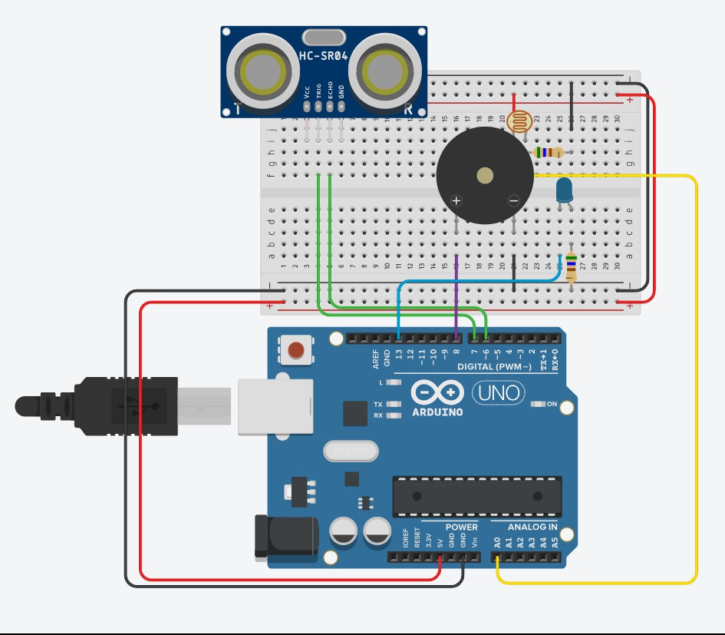

The Circuit on Tinkercad: <https://www.tinkercad.com/things/jVOwLIto8ZN-medical-project>

# How The Project Works

First, The ultrasonic sensor measures the distance between the object to be sterilized and the box-as we will put the object in a box and close it-and if the distance is less than the box distance, this means that there is an object, and if the distance is larger than the box distance then their is no object(box distance is a variable we put in the code to indicate the distance between the object and the box) .

Second, LDR detects whether their is no light or not, and hence the sterilization process starts if their is no light. so we calculate the resistance of the LDR and if its greater than 100 i. e no light or Dark)then the sterilization process begins.

So, the sterilization begins only if the LDR value is greater than 100 and the distance between the object and the box is less than (box distance).

Third, UV light is turned on for 5 seconds (sterilization begins) after Which a Buzzer sound Is generated, which means that the sterilization process ends, also if the box is opened before 5 seconds, UV light is turned off.

# Problems we faced

How to generate the beep sound only if the following scenario happened: the sterilization process was completed successfully with no any interruption or opening of the box through the past 5 seconds, and this was solved using Timer1 and ISR.